11.3 Haber process
Name: ____________________ Class: ____________________ Due date: 11.9
1. Ammonia is made by the Haber process.
$$N_{2}(g)+3H_{2}(g)⇌2{NH}_{3}(g)$$
a.State one major use of ammonia.
..................................................................................................................................[1]
b.Describe how hydrogen is obtained for the Haber process.
.................................................................................................................................
..................................................................................................................................[3]
c.This reaction is carried out at a high pressure, 200 atmospheres.
State, with an explanation for each, two advantages of using a high pressure.
.....................................................................................................................................
.....................................................................................................................................
...................................................................................................................................[5]
2. This question is about nitrogen and some of its compounds
(a) Nitrogen in the air can be converted into ammonia by the Haber process. The chemical equation for the reaction is shown.
$$N_{2}(g)+3H_{2}(g)⇌2{NH}_{3}(g)$$
(1) State the temperature and pressured in the Haber process
Temperature.............................. Pressure...................................
(2) Name the catalyst used in the Haber process
......................................................................
(b) The ammonia produced in the Haber process can be oxidised to nitrogen(ll) oxide at 900℃The reaction is exothermic.
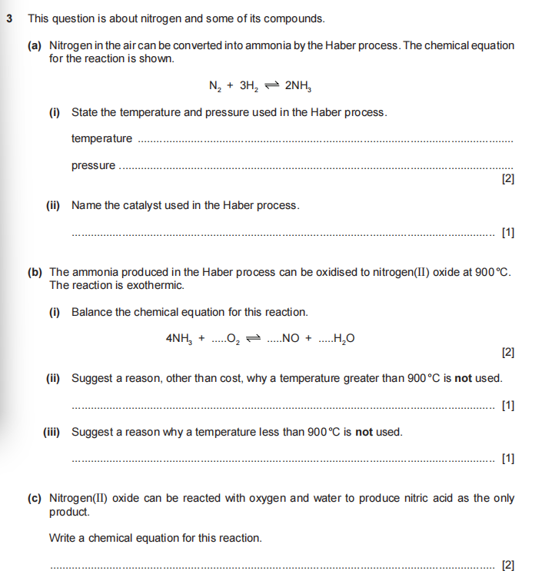
(i)Balance the chemical equation for this reaction
(i)Suggest a reason, other than cost, why a temperature greater than 900'C is not used........................................................................................................................................................................................................................................................................
(c)Nitrogen(ll) oxide can be reacted with oxygen and water to produce nitric acid HNO₃ as the only product.
Write a chemical equation for this reaction.
......................................................................................................................................
2. Ammonia is manufactured by the Haber process.
$$N_{2}(g)+3H_{2}(g)⇌2{NH}_{3}(g)$$
The forward reaction is exothermic.
a.Describe how the reactants are obtained.
i.Nitrogen
.....................................................................................................................................
.....................................................................................................................................
ii.Hydrogen
.....................................................................................................................................
.....................................................................................................................................
b. The percentage of ammonia in the equilibrium mixture varies with temperature and pressure.
Which pair of graphs, A, B or C, shows correctly how the percentage of ammonia at equilibrium varies with temperature and pressure?
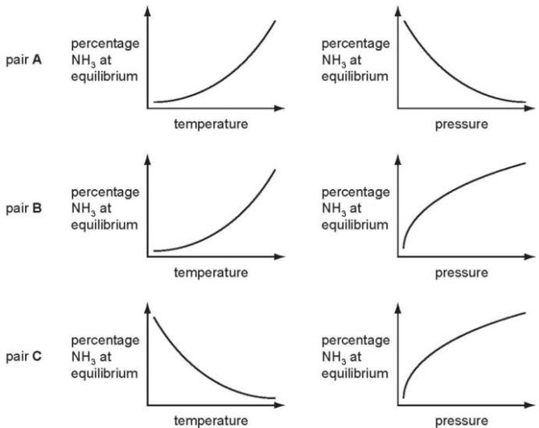
The pair with both graphs correct is
ii.Give a full explanation of why the pair of graphs you have chosen in (i) is correct.
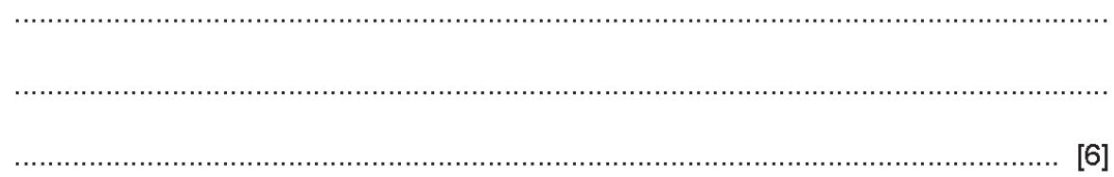
Catalysts do not alter the position of equilibrium.
Explain why a catalyst is used in this process.
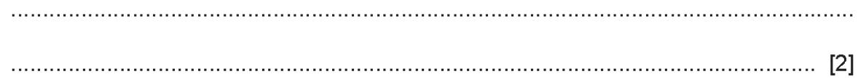

3. State one source of hydrogen used in the manufacture of ammonia.
The table shows some data for the production of ammonia.
pressure /atm | temperature /℃ | percentage yield of ammonia
250 | 350 | 58
100 | 450 | 28
400 | 450 | 42
250 | 550 | 20
Deduce the effect on the percentage yield of ammonia of:
increasing the pressure of the reaction......................................................................
increasing the temperature of the reaction.................................................................
c.Explain, in terms of particles, what happens to the rate of this reaction when the temperature is increased.
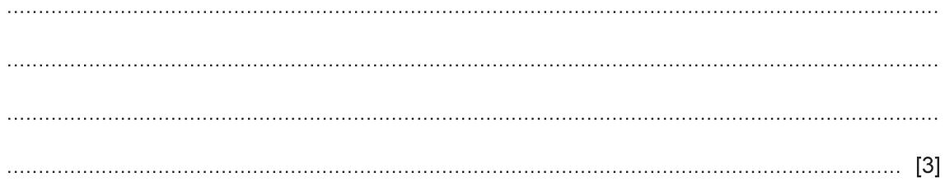
4 .a.Nitric acid is now made by the oxidation of ammonia. It used to be made from air and water. This process used very large amounts of electricity.
Air was blown through an electric arc and heated to ${3000}^{∘}C$
$$N_{2}(g)+O_{2}(g)⇌2NO(g) equilibrium1$$
nitric oxide
The equilibrium mixture leaving the arc contained $5\%$ of nitric oxide. This mixture was cooled rapidly. At lower temperatures, nitric oxide will react with oxygen to form nitrogen dioxide.
$$2NO(g)+O_{2}(g)⇌2{NO}_{2} equilibrium2$$
Nitrogen dioxide reacts with oxygen and water to form nitric acid.
i. Suggest a reason why the yield of nitric oxide in equilibrium 1 increases with temperature.
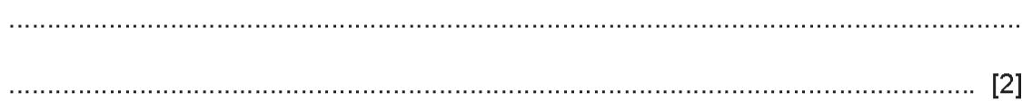
ii.What effect, if any, would increasing the pressure have on the percentage of nitric oxide in equilibrium 1? Explain your answer.
Iii. Deduce why equilibrium 2 is only carried out at lower temperatures.
iv.Ammonia is more expensive than water and air. Suggest a reason why the ammonia-based process is preferred to the electric arc process
b. Nitric acid is used to make the fertiliser ammonium nitrate, $NH_{4}NO_{3}$ .
What advantage has this fertiliser over another common fertiliser, ammonium sulfate, $(NH_{4})_{2}SO_{4}$ ?

5. Ammonia is made by the Haber process.
$$N_{2}(g)+3H_{2}(g)⇌2{NH}_{3}(g)$$
The forward reaction is exothermic. The conditions in the reaction chamber are:
a pressure of 200 atmospheres, a catalyst of finely divided iron, a temperature of 400 to ${450}^{∘}C$
a.What are the two advantages of using a high pressure?
Give a reason for both.
advantage 1 ..................................................................................................................
reason ..................................................................................................................................................................................................................................................................
advantage 2 ..........................................................................................................
reason............................................................................................................................................................................................................................................................... [4]
b. A higher temperature would give a faster reaction rate. Why is a higher temperature not used?
...........................................................................................................................................................................................................................................................................[3]
c. i.Why is the iron catalyst used as a fine powder?
................................................................................................................................. .........................................................................................................................................[1]
ii.Give two reasons why a catalyst is used.
.............................................................................................................................. .........................................................................................................................................[2]

